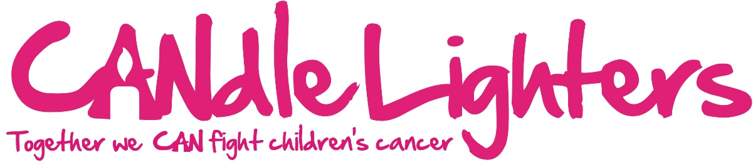
Skydiving Registration Form

FULL NAME
ADDRESS
 |  |  |  |  | POSTCODE
EMAIL
PHONE
DATE OF BIRTH |  |  |  | Age on date of jump
Height |  | Weight (max 16st) |  | Medical conditions |  | Yes / No | Recent or recurring injury or on medication |  | Yes / No
Please tick here if you would like to jump with the Candlelighters team on Sunday 29th March 2015 (last entries on Friday 30th January 2015) or alternatively enter your chosen date and an optional alternative below.
Preferred jump date |  |  |  | Alternative

SKYDIVING TERMS –
By taking part in a skydive in aid of Candlelighters you are bound by the following terms and agree:
- To aim to meet the minimum fundraising target set by the charity which must be submitted 5 days before your jump at the latest, otherwise you will cover the remaining amount yourself and/or pull out of the event and refund all monies to the sponsors.
- To make every effort to exceed the minimum target
- To send on any additional funds raised directly to Candlelighters within 3 months of your skydive. Failure to do so is considered theft.
- To make clear to sponsors if you are not paying for the skydive yourself and that the cost will be covered with their donations.
- That your contact details will be shared between the charity and the skydiving centre. They will not be passed on by us to any other third party for any reason.
- Skydiving is an adventure sport and participation involves a risk of injury or death and you voluntarily accept all the risks inherent
- That the organiser/ charities will not accept any liability or responsibility for you taking part in a skydive
- Skydive Hibaldstow have the right to postpone your skydive due to poor weather
- I have read and agree to the terms above.
- I am aware of the age, weight and medical restrictions for the skydive
- I enclose a non-refundable deposit of £50 to secure my place

Name (printed)……………………………Signed………………………………………….Date………………………

How to pay your deposit:
- Please complete this form and return to the Candlelighters office along with your £50 deposit. Cheques made payable to ‘Candlelighters’. If you would like to pay using a card please call 0113 247 0372 or pop in and see us.

Candlelighters, Children’s Oncology Day Unit, C Floor Clarendon Wing, Leeds General Infirmary, Great George St, LS1 3EX
Email: info@candlelighters.org.uk Tel: 0113 247 0372

