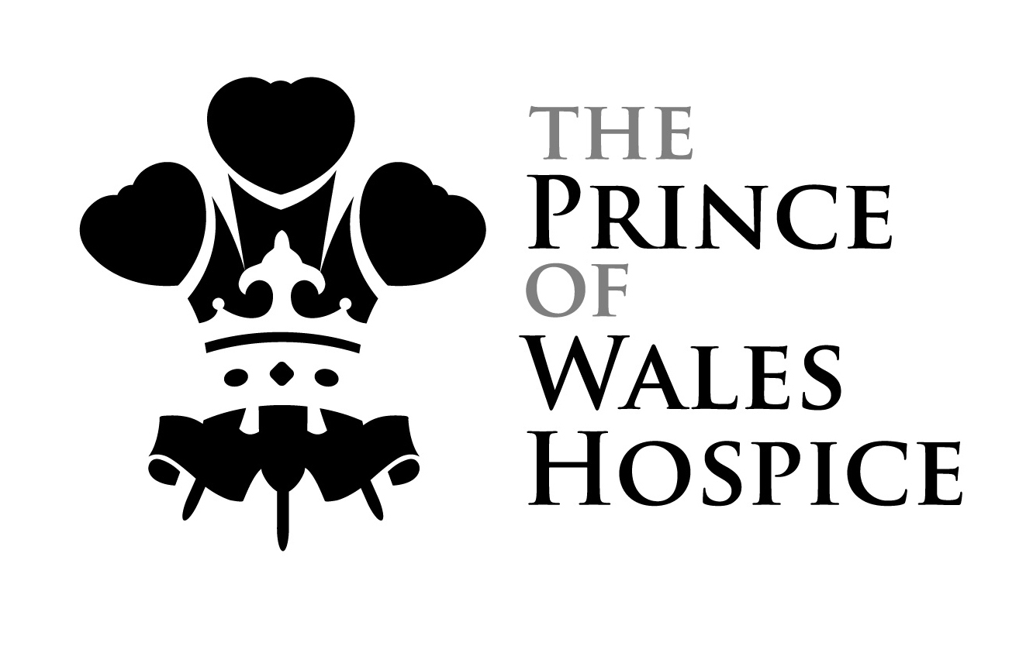
Dear Fundraiser,

Thank you for enquiring to make a sponsored skydive

Who your sponsorship will help – a little about our charity
At the Prince of Wales Hospice we are passionate about supporting people with life-limiting illnesses and their families in a positive, caring and practical way. We think of ourselves as an integral part of The Five Towns community, offering round-the-clock support 365 days a year. All of our care is free of charge to all our patients. But it is not free to provide. It costs us more than £6,000 a day to stay open, but we only receive about a third of this from the NHS. We need to raise around £4,000 a day to continue making a difference.

What kind of skydive will I be doing?
A Tandem skydive allows you to enjoy one minute of freefall harnessed to the front of a fully qualified instructor and you simply need a short 20 minute briefing beforehand as it is the instructor who opens and lands the parachute. This type of skydive is open to most people however there are a few age, weight and health restrictions so please check before booking. It will be the most exhilarating experience of your life!

How much do I have to fundraise?
In order to take part and effectively jump for free the Prince of Wales Hospice asks you to raise a minimum amount of £395 in sponsorship money. This amount covers the cost of the Tandem jump which is £200 paid to Skydive Hibaldstow who offer a discounted price and a minimum donation of £195 that will come to the charity. Every extra penny that you raise over the minimum comes straight to us, so please try to raise as much as you possibly can!

When Can I jump?
Prince of Wales schedules several event dates each year which we encourage you to join, but you can also book for any date the skydiving centre has availability if you prefer. For upcoming available dates please contact us.

How to take part
- Complete the ‘Skydiving Registration form’
- Reserve a place on your chosen date by paying a deposit of £50
This deposit will be deducted from the total amount of sponsorship you have to raise.

- Cheques payable to The Prince of Wales Hospice and send with the signed registration form to :
'Skydive', The Prince of Wales Hospice, Halfpenny Lane, Pontefract WF8 4BG.
- Call Katie on 01977 781479 to make a card payment and email the booking form to kmoore@pwh.org.uk or post to above address.
- Or make a card payment in person at The reception of The Prince of Wales Hospice.

- Start fundraising! You will be provided with official sponsorship forms to collect donations from friends and family and you can also register to fundraise online via www.justgiving.com/pwh

- On the day of your skydive you will need to

- Arrive at the airfield at the designated time and register in the reception.

- If you are aged 40+ or have a medical condition you will also need to hand in your BPA medical form signed and stamped by your doctor. If you are aged 16 or 17 then you will need a parent present to sign consent on three forms.

- Pay the balance of £150 for the skydive in cash or by card
- Hand in a sponsorship cheque for the minimum amount of £195 payable to ‘Prince of Wales Hospice.
- If you have fundraised online please be sure to notify us of your justgiving account details and bring a print out along with you on the day.

- If you would like the DVD and photo package then you will need to pay for this yourself on arrival.

- Complete 20 minutes of training with your instructor
- Enjoy your Tandem Skydive from 15,000ft!
Who can take part in a Tandem Skydive?

AGE RESTRICTIONS - Tandem Skydiving
- Overall age range: 16 years and older. There is no upper age limit for tandem skydiving.
- Age 16-17: Parental consent will be required. This is in the form of parental/guardian signature on the Skydive Hibaldstow membership form, BPA Tandem medical form and BPA membership agreement form.
- Age 16-39: Students will be required to sign a tandem student self-declaration medical on arrival.
- Age 40 and over: Students must have a BPA Tandem medical form stamped by their doctor.

WEIGHT RESTRICTIONS - Tandem Skydiving
- Maximum weight: 16 stones (100kg) for both males and females
Although it is less important to be physically fit for a tandem skydive, students must be aware that some wind conditions are less suitable for students who are less physically fit, less agile, in particular those with a high Body Mass Index of 27.5 or over and/or are close to the weight limit or for those with physical disabilities.
These students may have to wait for more favourable weather in order to complete their skydive, particularly if winds are light and this could result in the skydive being postponed to an alternative date.

MEDICAL CONDITIONS AND NOTES
Certain medical conditions (for example, epilepsy, some cardiovascular and neurological conditions and some forms of diabetes) or recurring injuries (for example, recurring dislocations) may preclude you from participating in a skydiving course. If you are in any doubt, please contact the parachute centre or consult the notes on the BPA Tandem medical form for more detailed information.
We reserve the right to refuse training or to postpone a jump if weather conditions or other factors are deemed not suitable for an individual student at the Centre Chief Instructor's discretion. It should be noted that not all weather conditions may be suitable for all students.

What about insurance?
The only type of insurance included is the mandatory membership to the British Parachute Association. There is no medical or personal accident insurance included. However if you would like to take out a one-off tandem jump policy then this is your choice. We cannot provide or recommend insurance however there are several companies that offer this including Extreme Plus www.sky-cover.co.uk or call 0844 8921515

Prince of Wales Hospice Contact details
Katie Moore
Tel : 01977 781479 / Email : kmoore@pwh.org.uk
Address : The Prince of Wales Hospice, Halfpenny Lane, Pontefract WF8 4BG
Find us on Facebook : www.facebook.com/theprinceofwaleshospice

If you need any information about the skydive itself or the age, weight and medical restrictions then you can contact the Skydive Hibaldstow Booking Office directly on telephone number 0113 250 5600 or email info@skydiving.co.uk as they are in the best position to answer any questions.

Your support means a great deal to us. Good luck with raising your sponsorship and we look forward to hearing from you soon.

CHARITY SKYDIVING TERMS - By taking part in a skydive for charity you are bound by the following terms and agree:

- That if you intend to cover the cost of the skydive with sponsorship money you will aim to meet the minimum fundraising target set by the charity, otherwise you will cover the remaining amount yourself and/or pull out of the event and refund all monies to the sponsors.
- To make every effort to exceed the minimum target
- To send on any additional funds raised directly to the charity within the timeframe agreed.
- To make clear to sponsors if you are not paying for the skydive yourself and that the cost will be covered with their sponsorship money
- That your contact details will be shared between the Prince of Wales Hospice and Skydive Hibaldstow, but your details will not be passed on by us to any other third party for any reason.
- Skydiving is an adventure sport and participation involves a risk of injury or death and you voluntarily accept all the risks inherent
- That The Prince of Wales Hospice will not accept any liability or responsibility for you taking part in a skydive.

