SKYDIVE HIBALDSTOW
CHARITY GROUP INFORMATION SHEET

Here at Skydive Hibaldstow, we pride ourselves in working alongside and supporting multiple charities by offering a unique and thrilling experience for their fundraisers. A tandem skydive gives the participant the chance to experience 120mph during freefall and up to 5 minutes under canopy, whilst harnessed to one of our British Skydiving qualified instructors. Our courses range in altitude between 10,000ft and 15,000ft.

The dropzone has a capability of up to 40 jumpers per day, holds high safety standards, has amazing charity rates, alongside great facilities for both participants and spectators. It's a perfect way to get together and raise some funds.

Approximately 50% of all our tandem business comes from charity fundraisers, so we know how to make your fundraisers feel like a team on the day and give them a worthwhile adrenaline-filled experience.

Who can take part?
We will send you our easy guide in regards to who can participate but we have jumpers from age 16 and our oldest participant to date was 94.

Height and weight restrictions do apply and all participants must sign a self-declaration medical or seek the advice from their GP.

How much?
Providing you are a registered UK charity (or organising a jump on behalf of one), we have 2 amazing rates for our 15,000ft tandem Skydive.

Option | Cost
Weekends | £209
Midweek (opening times vary on the month) | £179
Video and photo package (advanced bookings only) | £99

When?
We can reserve spaces for you on set dates, so you can offer these to your fundraisers. Our time slots go up to a max of 10 people, but you can choose to reserve several or even take the whole day. We are happy to hold the spaces up until a month prior, after which spaces will be released back onto public sale and become subject to availability. We will need the full jumper’s details and the £75 non-refundable deposit (unless we are invoicing for the full amount) to secure the space. Alternatively, you can opt for a more as and when needed booking style.

We are happy to work with you to find the best solution to organise your group, either with handy forms to send out or secure online payment links. Once booked, we provide all the information and forms required prior to the day, so you and your participants can focus on raising funds and getting excited.

On the day, our team will make your participants feel welcome and most importantly safe with a 20 minute briefing and plenty of opportunities to ask all the questions.

For more information or to secure your booking contact the team on the details below.

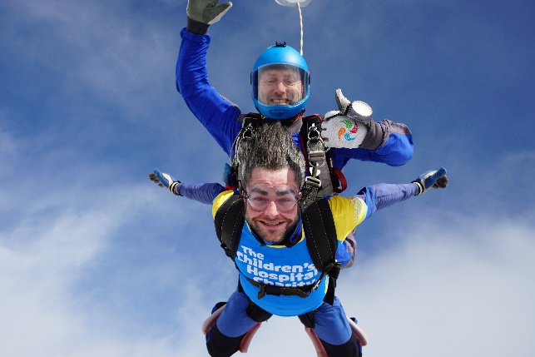

V1.0 Oct 2022

